

**Green and Sustainable Computing :**

**Project Final Report**

**Developing a green IT strategy for your own organization**



**Project Submitted to:**

**Prof. Radha Krishna Pillai**

**Department of Information Technology and Systems**

**IIMK**

**Submitted by:**

|  |  |
| --- | --- |
| **Name** | **Roll Number** |
| Anirban Roy Choudhury | EEPITM-01-001 |

Contents

Introduction 3

Current ‘Greenness’ of Organization 3

Why Green? 4

SWOT Analysis 5

Strengths 6

Weaknesses 6

Opportunities 7

Threats 7

Developing Green IT Migration Strategy – Solutions 8

Green IT Score – Measurements 15

Conclusion 17

Questionnaire 18

References 18

Disclaimer 18

Self Certification For The Project 19

# Introduction

Growth of Green IT means fostering economic growth and development while ensuring that natural assets continue to provide the resources on which our well-being relies. A return to “**business as usual**” would be unwise and ultimately unsustainable. Non green way of doing business could involve risks that could impose human costs and constraints on economic growth and development. It could produce water scarcity, air and water pollution and climate change which could be irreversible in future. For decades, the business community has mainly viewed the Environment as a cost to be avoided or marginalized. Today, a perceptual shift is occurring, i.e. today public is aware of the concept of “going green,” which implies environmental sustainability and reducing greenhouse gas emissions. General consumers, lawmakers, investors to governments, and other stakeholders are becoming increasingly convinced that human consumption is capable of overwhelming the ecosystem. Therefore, “**going green**” may or may not be a priority, but companies have no other option but to ride the “**green wave**” or get knocked over by it. Traditional green IT strategies have focused on the data center alone, which accounts for only 2% of global CO2 emissions. For IT to impact the other 98% requires a new approach — in which realizing energy efficiencies throughout the organization and dramatically reducing environmental impact and energy costs. Implementing green technology is quickly rising to the top of every organization’s agenda as it takes a tremendous amount of energy and money to power data centers, networks and computers.

Therefore, this project explores the current Green initiatives in the organization, the driving factors for Green IT for the organization, the benefits for moving towards Green IT via SWOT analysis, Strategy for the organization to migrate to Green IT and the relevant solutions.

# Current ‘Greenness’ of Organization

'McAfee (An Intel Company)' believes in Green initiatives such as to live life in a way which is friendly to the natural environmental and is sustainable for our plane. The only means is to contribute towards maintaining the natural ecological balance in the environment, and preserving the planet and its natural systems and resources.

McAfee (An Intel Company)' is also committed to taking steps, big and small, to minimize the harm we do to the environment and strive our best to reduce the carbon footprint we leave behind as a result of inhabiting this planet.

In practice, following five basic principles are adopted:

a) Protect the Earth’s Ecological Balance  
b) Conserve Resources   
c) Reduce Consumption and Waste   
d) Conserve Energy  
e) Reduce Pollution

Presently, wide ranges of activities are planned throughout the year. Below are some of the mass events planned.

1) **Tree planting** - Exploring opportunities in getting the help of Horticulture Dept.

2) **Save/Reduce Usage of paper** --- Exploring opportunities for avoiding/reduction in printing of routine jobs

3) **Carpooling** --- Collate and share the data of all carpool volunteers along with the routes and timings of coming and leaving office

4) **Public/Mass transport day** --- One day in a month can be observed as use Public transport/mass transport system.

5) **Use Handkerchief say no to tissues** --- Observe one day in a week as “no tissue day” in all Pantries and cafeterias

6) **Switch off AC for 1hour** --- Explore possibility of switching off AC for 1 hour a day either during lunch hour or towards evening time

7) **Using more LED/CFL** --- Explore energy saving options for new locations by using LED/CFLs

8) Using Aerosol free chemicals for cleaning purposes

# Why Green?

Now the question is why Organizations need to be ‘Green’ at all? Why ‘Green’ concepts are becoming popular in Enterprises? Does Green IT really work for an organization? We will find the major drivers for ‘Green Businesses’ which are actually answers to these questions. People are becoming more conscious of climate change, rising energy costs, and the dangers of hazardous materials. Therefore, being ‘Green Organization’ addresses following issues:

* **Environmental responsibility:** The need to consider the well-being of the environment, Global climate change and protect the health, and diversity of human and natural resources when doing profitable business. This addresses CSR (Corporate Social Responsibility) for an organization and these activities creates a good branding in society for the organization.
* **Sustainable development:** Defined by the United Nations’ Brundtland Commission as “development that meets the needs of the present without compromising the ability of future generations to meet their own needs.”
* **Resources IT uses:** IT consumes lot of electricity. This consumption of Electricity by IT can only grow with IT’s growth. Therefore, this consumption of enormous power by Organizations is actually threatening the Financial Resources of an Organization. For example, IT equipment’s produces lot of heat which needs to be removed by special cooling mechanism which in turn requires more Electricity.
* **IT turns over its equipment every three to five years:** Capital equipment in other departments lasts much longer, so greening new investments in IT have impact sooner. If organizations need to replace a computer or IT system, then they need to look for more energy efficient equipment’s.
* **Energy costs:** IT can significantly reduce energy costs. According to the Global e-Sustainability Initiative (GeSI, www.gesi.org), the IT industry could save global industry $800 billion dollars in energy costs by 2020 by implementing energy-efficient policies.
* **Equipment costs:** Greening IT optimizes business processes by consolidating servers and storage, which in turn results in needing less equipment, servers etc. and this process results in less consumption of power and requires less cooling for organizations.
* **Legal & Compliance issues:** Today there are lot of legal & compliance issues for organizations with respect to environment. Not complying with laws may result in heavy fine for companies. For example, the UK Government has announced that under the Companies Act 2006 (Strategic and Directors’ Reports) Regulations 2013, quoted companies are required to report their annual greenhouse gas (GHG) emissions in their directors’ report. International Standards have been developed such as ISO 14064-1 and the Greenhouse Gas Protocol which allows for consistent and comparable reporting of emissions

Following diagram shows various drivers for Organizations for adopting Green IT.

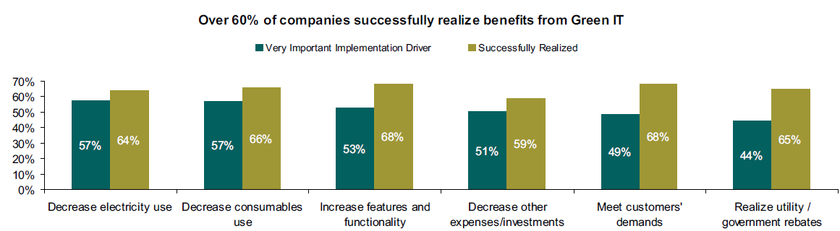

# SWOT Analysis

Till now we have seen the current ‘Greenness’ of the organization and major drivers for migrating an organization to the complete Green IT solution. We will do a SWOT analysis before we form a framework to migrate the organization to complete Green solution. SWOT is the first stage of planning and looks at the Strengths, Weaknesses, Opportunities and Threats involved in a project or business venture. Strengths and weaknesses are internal dimensions i.e. they are within the control of the organization. They may refer to the aspects of marketing, finance, manufacturing or organization. Opportunities and threats are actually external dimensions i.e. they are outside the control of the organization. These may include the outside environment, countries economic situation, social changes or technological advances. Exhibit below shows the internal & external categories for SWOT   
A business can produce opportunities and counter threats by making the most of its strengths and addressing its weaknesses.

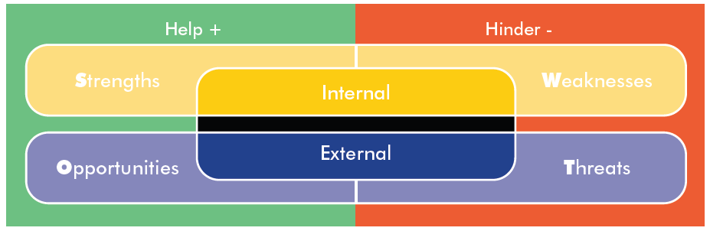

## Strengths

McAfee’s (An Intel Company) strengths are following.

* A strong global brand which attracts key consumer groups. It promises the best quality and range of products worldwide in security market.
* Its vision – ‘To keep people safe from online threats’
* Offering a wide range of security products at low prices
* Intel chip integrated security offerings to consumers
* More focus on online channels for product delivery, this slashes handling costs, reduces road miles and lowers the carbon footprint.

## Weaknesses

This needs to be addressed to formulate future company objectives and strategies. McAfee’s key weaknesses could be as below.

* The size and scale of its global business. This actually makes it hard to control standards and quality across the board.
* The need for low cost of production. This aspect needs to be balanced against producing good quality products via energy efficient means.
* McAfee needs to keep good communication with its consumers and other stakeholders about its environmental initiatives. The scale & spread of the business makes it a difficult task. However, green branding should impact positively.
* More energy efficient and green processes for product development and maintenance.

Opportunities  
Businesses uses strengths to take advantage of opportunities. Some of the opportunities with respect to the sustainability agenda that McAfee can take advantage of are:

* A growing demands for greener products – This can be achieved with sustainable use of resources. McAfee can aim for zero waste to landfill, wastewater treatment and programmers to reduce its use of water.
* A growing demand for low priced products. – Energy efficient processes and low cost power consumption (generating electricity in non-conventional way) will automatically reduce costs.
* Demand for products with lower carbon footprints. – McAfee can aim to reduce energy usage, can try to use more renewable form of energy, cut its use of air transport and reduce packaging. It can also initiate green transport program which could aim to reduce business flights by 20% by 2015.
* Developing social responsibility. McAfee’s policy can include support for charities such as the World Wildlife Fund, UNICEF and Save the Children. Being open with all its stakeholders which involves building trust through good communication with consumers, co-workers etc. This helps to build a sustainable environment with strong sense of greening.

## Threats

When a company is aware of its possible external threats then it can easily plan to counteract those. McAfee can use existing strengths to defend against threats along with new ideas. Threats to McAfee along with solutions could be following.

* Market trends – such as the slowdown in buyers entering the traditional client-server security market. This is a core market segment for security products. – Green product strategy with cloud delivery model can be solution to this threat. Organization can educate customer and provide support for green product benefits via website.
* Market forces – more competitors entering the security market. McAfee needs to reinforce its unique qualities to compete with these. Greening security products could provide a competitive advantage and green strategy will lower the cost of product development and maintenance. This can also put up ‘High barriers to entry’.
* Economic factors – the recession slows down consumer spending and disposable income reduces. By green IT strategy products can be developed with low cost and this in turn will help to price products very attractively.

From above analysis it can be seen that McAfee can use Green IT concepts to capitalize on ‘Opportunities’ when addressing external ‘Threats’. Green IT can reduce ‘Weaknesses’ and provide new business opportunities. Therefore, it is certain that organizations such as McAfee can get lot of tangible and intangible benefits while lowering costs by embracing Green concepts.  
**There is one business truth** – being sustainable and responsible is not just good for customers and the environment, it is also good for business!

# Developing Green IT Migration Strategy – Solutions

We have seen the benefits for migrating to Green IT solutions by SWOT analysis above. Now if we recall the current ‘Greenness’ of the organization then we can see that currently McAfee has taken few initiative for Greening but it is mainly at the event level and operational level initiatives are mainly aimed at paper saving and installing energy efficient PC monitors or laptops. Though there are Green principles defined for the organization but these Green Principles are still not completely aligned with top level Business Strategy to give the needed push forward to make the Enterprise Greener.   
However, following are some solutions which can be included in management strategy to migrate the Organization towards Green IT.

**Decommissioning unused systems:** - Systems that are never or rarely used but consumes power should be retired. Any relevant data or services can be moved to an alternate server.

**Power Management:** - Many employees in an organization do not shut down their Desktop machines which may not be accessed remotely. In these scenarios Power management tools and Remote systems management software can help IT administrators to enforce a power-off policy which may shut down or hibernate the PC or it may put to sleep every idle computer. Sleep and hibernation modes can reduce energy consumption by 60 percent, according to the nonprofit Climate Savers Computing Initiative. Today, there are tools available to IT Administrators to manage power consumption for Desktop PC’s which are on the network. These tools allow remote administration of power settings on every computer on the network, and can automatically shut down, hibernate or suspend PCs at night based on configurations. These tools can be used to deploy power usage policies for specific group of users which can include Wattage Settings as well. These tools also provide reports on the amount of power, kilowatt hours and dollars saved. Avocent’s LANDesk Management Suite, Hewlett-Packard' Verdiem Surveyor etc. are few names in this category of power management tools. Nowadays individual PC manufactures are also including power management features in their desktops; notebooks etc. and Organizations should prefer these PC vendors to migrate to complete Greener IT machines when purchasing Desktop, Laptop, Notebook etc. Following Exhibit shows organizations benefiting for power management and virtualization initiatives.

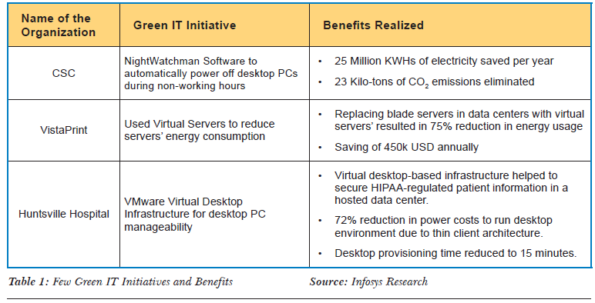

**Consolidation & Virtualization:** - Everything needs to be consolidated including applications, which are often overlooked. Over time an organization goes through lot of changes and in that process applications become redundant which needs to be identified to retire. For retiring servers, the older, single processor servers can be replaced with new servers powered by more energy-efficient dual-core and quad-core processors. By consolidating,

* Overall number of devices running in the data center or server room, along with the space needed to house these devices can be decreased significantly
* Energy needed to run servers and storage, along with the associated cost and greenhouse gas emissions can be decreased significantly.
* Cost of future investments in physical servers and storage devices can be decreased significantly. This consolidation will increase server utilization rate as well.

Another very useful consideration is reducing time needed for server maintenance and management by using Server Virtualization. IT departments can quickly change virtual server configurations and IT can completely avoid the time-consuming labor required by physical servers. Up to 60% of businesses report they will run out of processing or storage capacity within the year. Therefore, the traditional method of adding capacity & installing physical servers and hard disks are not only inefficient but produces budget constraints. The conventional model of adding hardware doesn’t scale well for cost savings. Another factor favoring virtualization and consolidation is electricity capacity. Many server rooms simply can’t handle the additional load of new physical equipment. Relevant issues & benefits organization survey exhibits shown below.

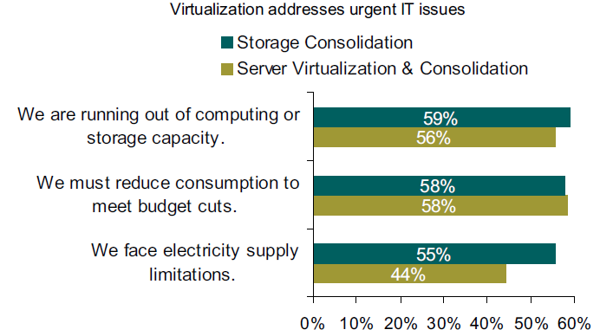

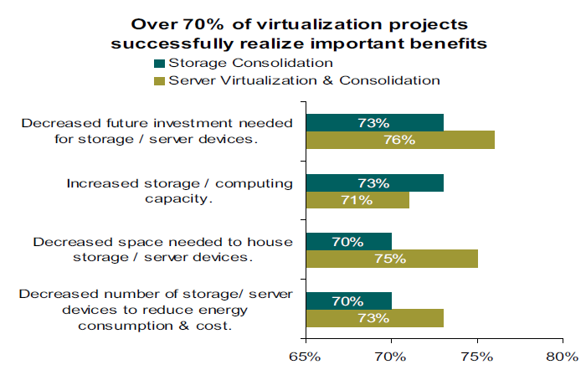

**UPS Systems: -** Uninterruptible power supply (UPS) systems can be migrated to newer and more efficient ones. New UPS systems maintain 97% efficiency meaning only 3% of incoming power is lost. In older UPS systems 20% to 30% of the power is leaked out as heat and device can only operate at 70 to 80 % efficiency.

**Energy-efficient computers and monitors: -** When organization replaces its IT equipment, Desktop, Laptop, Notebook, Monitors etc. then it should consider devices which meet stringent government energy efficiency standards such as **Energy Star or EPEAT** (Electronic Product Environmental Assessment Tool). U.S. government demands that 95 percent of all computers purchased should meet EPEAT standards. LED screens consume 30% less power when compared with LCD screens. Intel offers multicore processors that deliver increased performance, but at fewer watts. Intel processors can adjust its voltage & core frequency based on application load that result in decreased power consumption. Therefore, organizations should look at these types of energy efficient innovations to decide their IT device purchase to move the organization toward complete Green IT systems.

**Travel Reduction**: - This is an option taken by many organizations today to cut costs and to reduce negative impact on our environment by reducing Green House Gas emissions. Following options could be looked at to incorporate in the organization’s Green IT strategy.

* Video-conferencing and teleconferencing systems between facilities or between office and client sites.
* Remote access over VPN
* Strategies to encourage employees to work from home to reduce CO2 emissions

These Telecommuting strategies increases employee satisfaction as employees need not spend money for fuel purchase. Also, using Telework can open up avenues through which organization can tap into talent which were out of reach before. Organizations report that their employees are very much satisfied with the flexibility provided by Telework. Survey exhibit shown below.

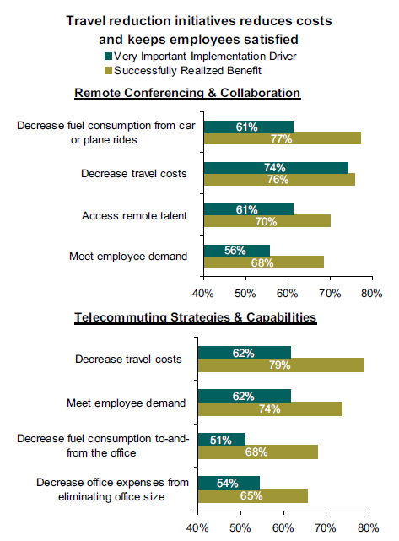

**Thin Clients**: - Organizations can move desktops to Virtual environments and providing thin client machines to employees reduces energy consumption and environmental impact. A thin client does not have CPU, RAM or any moving parts, and it connects to the virtual desktop environment. Typical computer uses up to a 250-watt power supply but thin client's uses a 4.8-watt power supply, so the reduction in power consumption usage is 97.98%, with all the functionality. This arrangement decreases maintenance & management costs significantly for organizations. Survey conducted with organizations for Thin client implementation benefits is shown in Exhibit below.

**Server Room Upgrades: -** It is observed that businesses can gain benefits by making server rooms greener either by upgrading data center facility or by constructing a new one. Following could be the reasons for doing so.

* Increased effectiveness of cooling and ventilation systems with reduced cost.
* Increase server & computing capacity to reduce number of servers to free up space in datacenters
* Server room infrastructure restructuring for up time & availability.

Datacenter or server room optimizations can achieve organizations goals such as reduced maintenance, increased reliability of the server room or data center and increased efficiency and cost effectiveness of air conditioning and ventilation systems. With respect to environmental standpoint, the benefit comes from more efficient use of each watt that enters the server room. This reduces energy costs for an organization with less CO2 emission, while computing capacity grows.

Exhibit below shows benefits derived by organizations by server room optimizations.

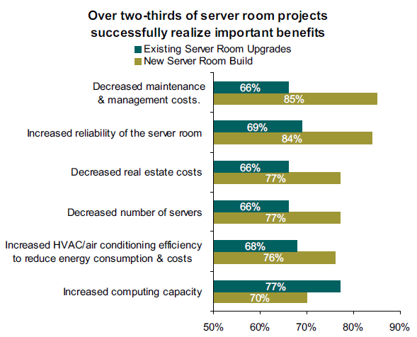

**Asset Disposal**: - E-Waste today constitutes 5% of all municipal solid waste generated worldwide. E-Waste contains hazardous materials such as toxic plastic, lead, cadmium, mercury etc. which causes serious damage to the Environment and human health. Developing nations suffers most for the hazardous E-Waste which usually migrate from developed nations. So, it makes sense for organizations to initiate IT Equipment Recycling or Re-Use programs which shows environmental responsibility (CSR) and secondly a Re-Sale program within organization for employees can be cost effective for Re-Use of IT Equipment’s by employees for their personal purposes. Re-Sale programs help to reduce Re-Cycling efforts in cost effective way. Recycling initiatives for IT Equipment’s are mainly to drive less waste to landfills and also to discard End of Life equipment’s in an environment friendly manner. These recycling initiatives can have intangible benefit of meeting client demand and tangible benefit of compliance with environmental regulations. Below survey result Exhibit shows the successful drivers for IT Equipment recycling.

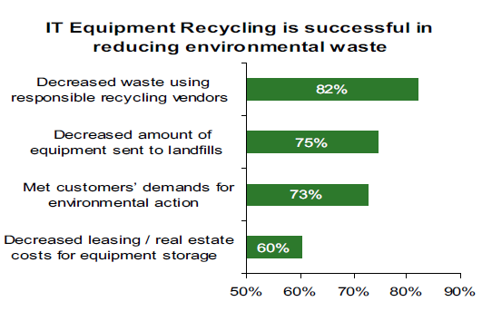

Therefore, a Green IT Strategy for this organization can include combination of the above described solutions to migrate to complete Green IT Enterprise. Information Technology Infrastructure Library (ITIL), can help prioritize solutions for the Green Strategy. ITIL recommends two principle criteria for choosing solutions i.e. how much value Green IT will bring to the business and how well they address critical pain points for an organization. In the case of green IT migration, both criteria are served satisfactorily by how much reduction in power would be provided by each solution.

# Green IT Score – Measurements

Finally, this is the saying: ‘**You can’t manage or improve if you can’t measure**’. Therefore, once Green IT solution is implemented organization need to monitor its effectiveness and returns and tweak the Green IT Strategy along the way. To do this organizations need to find out where the energy goes i.e. organizations need to derive how much Electricity is consumed by IT. Following steps could be used to measure IT electricity consumption in an organization.

* How much power goes to data center or server room – Sub-Metering for server rooms or data centers.
* Determining how much power each device use – This information is built into the devices.
* Add the power consumption of each device to assess total IT energy use.
* Powering equipment versus power distribution overhead - Figuring out IT equipment versus cooling and power distribution overhead

Energy measurements are mainly useful for following reasons.

* Clearly shows increasing or decreasing efficiency in energy consumption for current & future IT practices. This measure helps organizations to improve in lacking areas.
* Server room or data center energy consumptions are good candidate for CIO analysis for further improvements.
* Energy consumption data is very important for regulatory compliances and this data helps understanding environmental performance of an organization as well.
* Budgetary constraints for IT departments forces to measure energy spending to reduce power consumption.
* Energy measurement can be used as a Strategic Tool to improve current IT operations energy spending to future strategic choices for IT energy spending as a whole.

Following Exhibits shows how an energy measurement in an organization helps to spot issues and then to act on it to realize benefits.

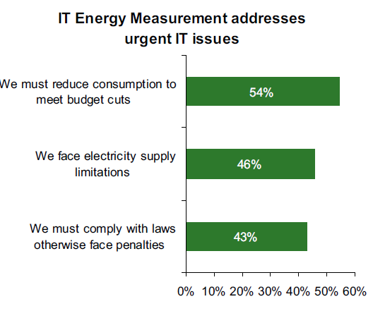

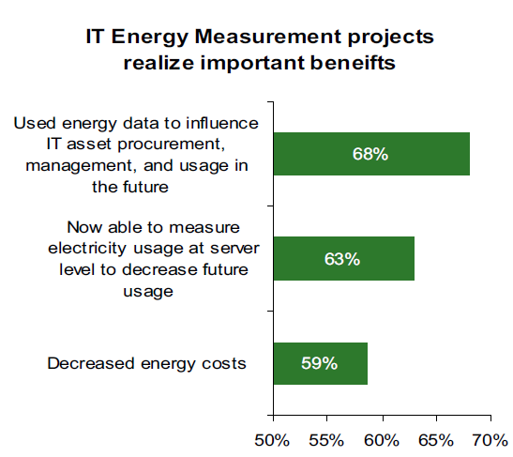

# Conclusion

In this project we have seen there are numerous solutions available for organizations to achieve Green IT goals but it is the desire of companies to effectively integrate these Green Solutions to their Business Strategy to derive effective results. Measurements metrics are very important to determine the IT energy spending pattern in an organization. Measuring energy to avoid wastage of power in an organization will develop an energy efficient attitude among employees.

All over the world businesses have discovered that going green is not only good for the environment but it is also good for the business. Migrating organizations to Green produces significant cost savings. Today clients & affiliates are more aware of environmental issues and they demand greater environmental accountability from organizations. Environmental issues nowadays are regulatory compliance & international treaty issues as well. Employees too also will demand environmental accountability from organizations and they may prefer telecommute for their job roles.

It is estimated that in future, every six in 10 businesses will run out of computing or storage capacity within 1 year. In these cases, modern virtualization and consolidation techniques will address pressing future business needs in a cost effective manner with energy-saving options.

This project shows that migrating to Green IT saves money, energy and can help realize new business capabilities. In future Corporate Environment Responsibility will become norm. Therefore, going Green is not only a trend these days but it’s really smart enough to provide real return on investments. Business requiring reducing operational cost, compliance with legal and needing to achieve long term IT Power Sustainability should consider migrating to Green IT for effective and environment friendly results.

Therefore, McAfee (An Intel Company) can form a Green Strategy to choose few of the above described solutions to take the Green IT initiative forward to turn the organization completely Green and can realize the benefits for the same.

# Questionnaire



# References

1. <http://www.oecd.org/greengrowth/48224539.pdf>
2. <http://www.deloitte.com/assets/Dcom-Belgium/Local%20Assets/Documents/EN/Services/be-cio-green-it-260110.pdf>
3. <http://www-304.ibm.com/businesscenter/cpe/download0/211179/greenit_fordummiess.pdf>
4. <http://www-03.ibm.com/press/attachments/GreenIT-final-Mar.4.pdf>
5. <http://businesscasestudies.co.uk/ikea/swot-analysis-and-sustainable-business-planning/introduction.html#axzz2kSRULAyG>
6. <http://www.cisco.com/web/strategy/docs/gov/cdw-g_green_it_wp.pdf>
7. <http://www.infosys.com/infosys-labs/publications/Documents/green-IT.pdf>

# Disclaimer

This project report may contain confidential data of an organization. It may only be used for academic purpose in teaching business administration at IIM Kozhikode. Confidentiality has to be maintained about the content. Publications and duplications of the content in any form are forbidden. For data privacy reasons certain names have been masked.

# Self Certification For The Project

This is to certify that **Anirban Roy Choudhury**, who is an employee of **McAfee (An Intel Company),** has done the project on ‘**Developing a green IT strategy for the organization**’ of the said organization as part of the Green **& Sustainable Computing** course of the Executive Post Graduate Programme in Management (2013-14) from Indian Institute of Management Kozhikode. The contents in the project report are true to my knowledge and the same must be used for academic purpose only.

Name: Anirban Roy Choudhury

Position: Sr. S/w Development Engineer

Organization: McAfee (An Intel Company)

Address: 1st and 2nd Floor, Pine Valley, Embassy Golf Link Business Park, Amarjyoti Layout, Domlur, Bangalore, KA

Signature: